IT 125-41194

Alex Arnold

4-14-25

Lab 11.6.1

Step 1: Create a Secure Trunk.

a. Connect the G0/2 ports of the two access layer switches.

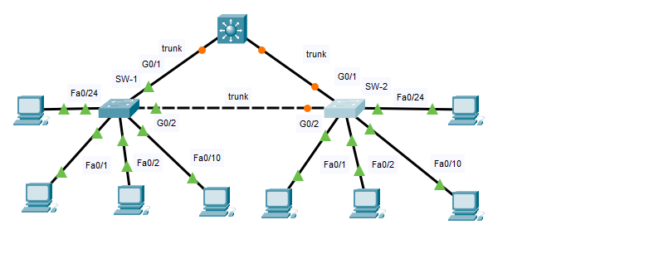

b. Configure ports G0/1 and G0/2 as static trunks on both switches.

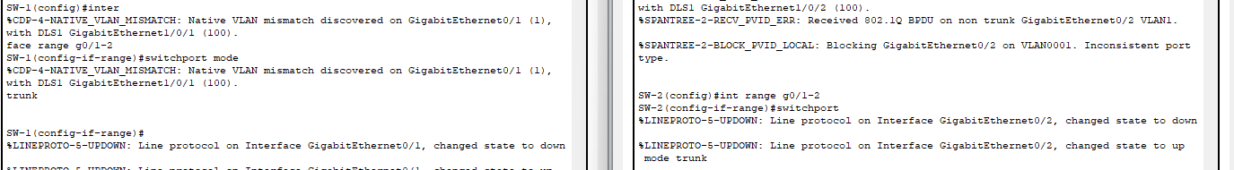

c. Disable DTP negotiation on both sides of the link.

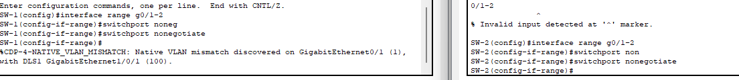

d. Create VLAN 100 and give it the name Native on both switches.



e. Configure all trunk ports on both switches to use VLAN 100 as the native VLAN.



Step 2: Secure Unused Switchports.

a. Shutdown all unused switch ports on SW-1.

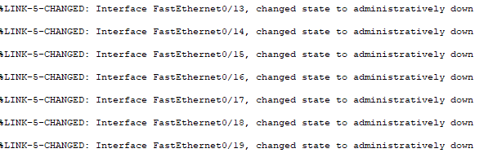

b. On SW-1, create a VLAN 999 and name it BlackHole. The configured name must match the requirement exactly.



c. Move all unused switch ports to the BlackHole VLAN.

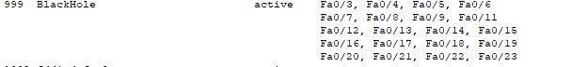

Step 3: Implement Port Security.

a. Activate port security on all the active access ports on switch SW-1.

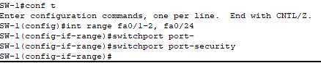

b. Configure the active ports to allow a maximum of 4 MAC addresses to be learned on the ports.



c. For ports F0/1 on SW-1, statically configure the MAC address of the PC using port security.



Couldn’t be done due to found duplicate mac-address glitch that could not be cleared (I tried all online solutions I could find)

d. Configure each active access port so that it will automatically add the MAC addresses learned on the port to the running configuration.



e. Configure the port security violation mode to drop packets from MAC addresses that exceed the maximum, generate a Syslog entry, but not disable the ports.



Step 4: Configure DHCP Snooping.

a. Configure the trunk ports on SW-1 as trusted ports.



b. Limit the untrusted ports on SW-1 to five DHCP packets per second.



c. On SW-2, enable DHCP snooping globally and for VLANs 10, 20 and 99.



Note: The DHCP snooping configuration may not score properly in Packet Tracer.

Step 5: Configure PortFast, and BPDU Guard.

a. Enable PortFast on all the access ports that are in use on SW-1.

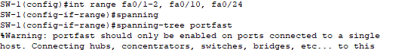

b. Enable BPDU Guard on all the access ports that are in use on SW-1.



c. Configure SW-2 so that all access ports will use PortFast by default.

